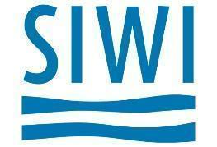
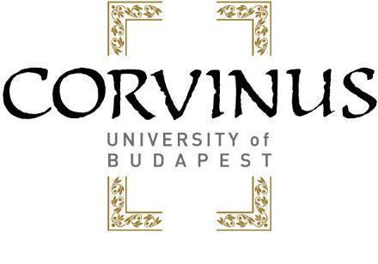
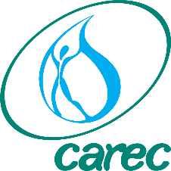

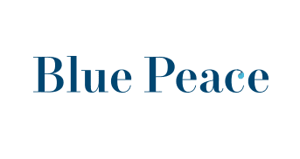

Water as a Driver of Sustainable Recovery: Economic, Institutional and Strategic Aspects of Water Resources Management in Central Asia

Call for papers on the topic

“Economic, institutional and strategic aspects of water resources management in Central Asia”

Competition for students and young researchers of Central Asian universities

In the framework of the Programme “Water as a driver of sustainable recovery: economic, institutional and strategic aspects of water resources management in Central Asia” the Center for Central Asia Research of Corvinus University, Budapest in cooperation with the German-Kazakh University, Almaty invites university students (MA and PhD), groups of students and young researchers (30 years or younger) to submit research studies on the topics discussed during the four webinars held in the framework of the Programme. The best studies (one on each topic) will receive a cash prize of Euro 1000, while second placed studies (2 on each topic) will receive a cash prize of Euro 500 each.

The best papers might be published in the open access, peer reviewed “Central Asian Journal of Water Research”.

The best authors might be invited to introduce their paper during the face to face workshop of the Programme planned in September 2021 in Almaty.

Papers can be submitted in Russian or in English to the Corvinus Center for Central Asia Research (marton.krasznai@uni-corvinus.hu).

Background
The Center for Central Asia Research of Corvinus University Budapest (CUB) is working closely with the Blue Peace Central Asia initiative of the Swiss Development Cooperation, the Stockholm International Water Institute and the Central Asian Regional Environmental Center to implement the programme consisting four webinars held between 3 November 2020 and 20 May 2021. The outcomes of the webinars will be introduced in August during the Stockholm World Water Week, at a face to face workshop planned in September in Almaty, during a side event on water at the first European Union - Central Asia Economic Forum in Bishkek (planned in October) at a side event of the “Planet Budapest” sustainable development summit (29 November - 5 December 2021).
Overall objectives
The overall aim of the project is to convincingly demonstrate that improved water resources management can provide a powerful boost to sustainable, green economic recovery after the covid-19 crisis. Analysis of economic, institutional and strategic aspects of water resources management will allow participants to elaborate short- and long-term recommendations to support decision makers at the national and regional levels.
Scope of work
The research studies should analyse the issues on the agenda of the four webinars:

- Post-covid-19 recovery strategies: putting the water sector of Central Asia on an economically and financially sustainable path: lessons, problems, opportunities” (3 November 2020)

- “Identifying essential structural and institutional reforms to achieve economic sustainability of the water sector of Central Asia” (25 February 2021)

- Outlining the economic foundations of regional cooperation on water in Central Asia (15 April 2021)

- “Strategic Aspects of Water Resources Management in Central Asia” (20 May 2021)

Documents (background papers, summaries, agendas) of the webinars can be found on the Blue Peace Central Asia/CAREC website: (https://carececo.org/en/main/news/news/vtoroy-vebinar-issledovatelskoy-programmy-voda-kak-dvizhushchaya-sila-ustoychivogo-vosstanovleniya-o/) or on the website of the Center for Central Asia Research of Corvinus University Budapest: https://www.uni-corvinus.hu/main-page/research/research-centres/corvinus-centre-for-central-asia-research/events/?lang=en

Proposed methodology
Upon request CUB is ready to give advice on data, sources and methodology to be used by the researchers.
The deadline for submitting papers is 31 August 2021
A group of experts invited by CUB will evaluate the papers.

