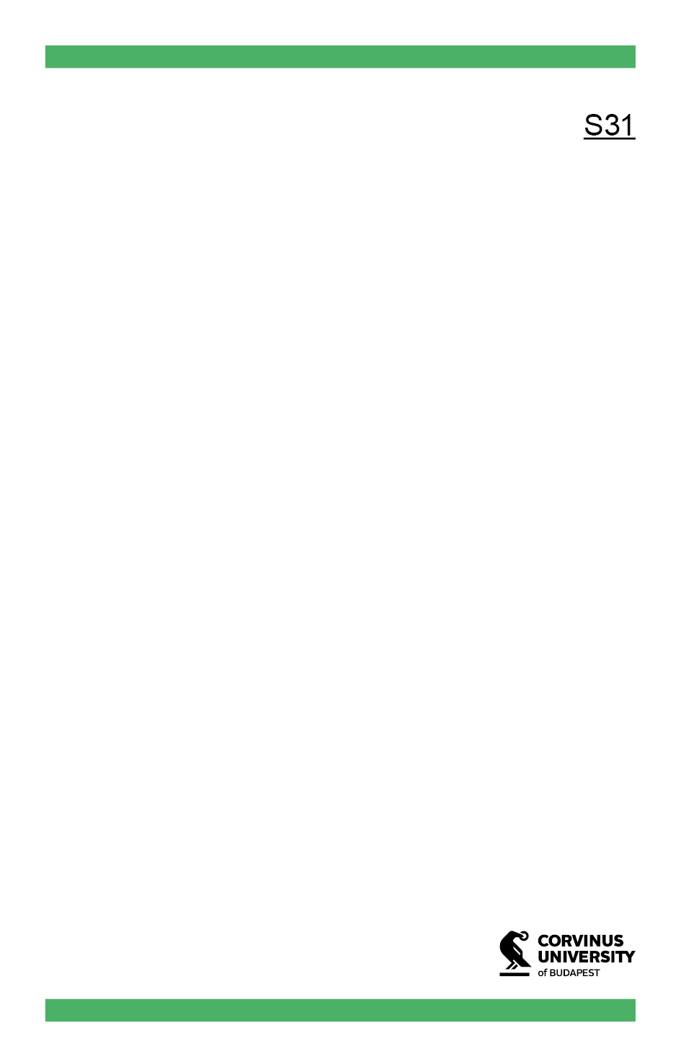

Department (English)

Job Title (English)

Job Title (Hungarian)

Department (Hungarian)

First Name

Surname

First Name

Surname

First Name

Surname

First Name

Surname

First Name

Surname

Job Title (English)

Job Title (Hungarian)

Job Title (English)

Job Title (Hungarian)

Job Title (English)

Job Title (Hungarian)

Job Title (English)

Job Title (Hungarian)

Job Title (English)

Job Title (Hungarian)

First Name

Surname



Department (English)

Job Title (English)

Job Title (Hungarian)

First Name

Surname

Job Title (English)

Job Title (Hungarian)

First Name

Surname

Job Title (English)

Job Title (Hungarian)

First Name

Surname

First Name

Surname

Job Title (English)

Job Title (Hungarian)

First Name

Surname

Job Title (English)

Job Title (Hungarian)

First Name

Surname

Job Title (English)

Job Title (Hungarian)

Department (Hungarian)